CULTURAL DIFFERENCES AND ETHICS

S3

Welles,Nick N.H.M.

2022 - 2023

Table of content

What are cultural differences 2

My experience with cultural differences 2

Internship at Whysor 2

Internship at Concrefy 3

Personality tests 3

My culture 4

Ethics in software engineering 4

Ethical choices 5

Individual project 5

Group project 5

Cultural Differences 7

Introduction 7

Culture 7

What is culture? 7

Which are well-known dimensions on cultural differences? 7

Ethics 7

What is ethics in software engineering? 7

Why is ethics important in software engineering? 8

What do you have to do as a software engineer to address ethical aspects in your work? 8

How do you know that your ethical considerations match with those of other software engineers? 8

# What are cultural differences

Wow I understand it is that while working, in a team, you have to take into account how people in your team approach assignments, questions, meetings, etc. People in your team may be from different countries, so you could talk to them about this to take into account their values and norms. What is also possible is that different cultures have a different form of communication. You might have a culture with an informal communication style, or a culture with a formal communication style. If this were to occur in your team, you would also have to take this into account. Sometimes there are conversations of which you think afterwards, what did I say there? and for what reason did it turn out this way? This is something you can think about if you want these kinds of conversations to run better in the future or in another country when you are on holiday.

# My experience with cultural differences

As long as I have been alive (which is not very long) I have experienced some differences with cultures. Simply put; I went on vacation once to Turkey, Greece, Germany and Ireland. It is always very nice to see what daily life is like in countries other than where you are originally from. At the beginning you are gaining a lot of information about how things work there in order not to offend or question anyone. Although most people can see that you are a foreigner there.

I have also worked with people of other backgrounds besides Dutch during my internships. I will elaborate on a few of these experiences below.

## Internship at Whysor

During my internship at Whysor, another intern joined at Whysor, his and country of birth was Iran. He understood a little Dutch, but the conversations we had with him and colleagues were all in English.

This did take some getting used to since you work at a company where the main language is Dutch, you switch between languages all the time when talking to different people. Of course, you get used to this the longer you are with each other.

Sometimes it was difficult to understand each other. You have words that you translate directly, but in your language, words can mean something different than that in the language of your conversational partner.

All in all, though, this is a good, and mostly fun experience. You laugh with each other, you exchange typical cultural things with each other which also makes you get to know each other better, even though sometimes it seems like you are very far apart. For example, one time we went to his place for dinner with the whole company, and everything he prepared came from Iranian cuisine. So you also learn rituals that they do for food and you get to see and eat many new dishes that you will probably never see in the Dutch cuisine. That was a good experience that only made the bond stronger.

When I think about it now, a few years later, I think it was a good experience to develop me as a better person. When I started my internship there, I hadn't quite found my niche and was still unsure about certain things. I think I occasionally took some risks in things I said/asked in conversations with him, but fortunately he knew how to deal with it which I think was also due to the big age difference. When I think of it now, maybe I could have asked some things more subtly. So I am definitely going to keep that in the back of my head for conversations like this that may occur in the future.

## Internship at Concrefy

At Concrefy, I was responsible for building a whole new website with various integrations regarding Marketing Automatization. During this process I was in contact with the person behind the marketing at Concrefy. Since Concrefy is located in the Netherlands as well as in Germany, I occasionally had conversations with German colleagues. Fortunately, the executive behind marketing could speak Dutch which made communication a lot easier.

Once a month they were in contact with the parent company in Austria. Then you sit in a meeting to get information about, for example, securing the website etc. Then they talk full-blown German and occasionally there is a word of English in between. Fortunately, I can understand German reasonably well, but when they try to talk faster, especially the Eastern version of German, or the dialect, then it is difficult to understand. At that point you realize that it is not necessarily the difference in culture, but also the difference in languages that is a barrier.

In these conversations, I felt less like I was thinking afterwards of, what am I doing? Around this point in my life, I started to understand pretty well how things worked and what I could and could not say to certain people. I think this was also largely due to my previous internship.

## Personality tests

During the course of semester 3, we had several workshops of information of certain topics. One of them included cultural differences and ethics. To conduct the workshop properly, we took two tests to discover your personality and what things define you as a person.

The first tests I did was a test to check which colour you are. Going between blue, yellow, green, red and white. I have got the most in common with the white colour, or so says the test. Closest to that are red and green. The test tells me that I have great motivation as an individual, but this also applies in a group setting. If something changes, that would be hard for me to adapt to.  
As typical proverbs there are a few listed but there is one that I use very often. ‘It is what it is’. I do say this a lot because we live with a lot of people in this country let alone on planet Earth. If things go as they go there is not much we people can do about it and that is something you need to accept in order to move on to the next problem, or challenge. At least, that’s how I think about it.

[View screenshot](eerste%20persoonlijksheidtest.png)

The second test was to determine which role you have in a group setting. Since we had a group project during this semester this was a very interesting test to see the results of.

The results which they think have the most in common with me as a person in a group setting:

* The business man is the organiser, works orderly and is practical. (17%)
* The group worker is the team's social antenna, ensures a good atmosphere in the team. (17%)
* The resource investigator is a networker and arranges contacts and ideas. (14%)

I do agree with these results. Entrepreneurship runs in our family's blood, I myself started a business in early 2021. So I don't find it very surprising that these results are so close to me as a person. I also like to be nice to people, no matter whether I know them or not. It has stayed with me since primary school: Treat others as you would like to be treated yourself. And that is also how I have come to behave towards other people pretty much all my life. I also like to learn and investigate new things. Since we are going to be IT professionals we have to adapt to newer technologies, that's probably is a good trait to have.

[View screenshot](tweede%20persoonlijksheidtest.png)

# My culture

It’s not easy to explain to everyone what my culture is. The term culture is a broad term. What I can say about this is that I was born in the Netherlands. According to the Lewis model, I then belong in the Linear-Active point. This means that I talk very often, that I can only do one thing at a time and that I am polite but direct. This is reasonably accurate but I don't quite agree. For example, when I'm working I sometimes do several things at once. You get a phone call in between, for example. I can talk a lot if I feel like it and I often stick to facts. If I have doubts, I will investigate. But in general, what is said here about Dutch culture/people is true.

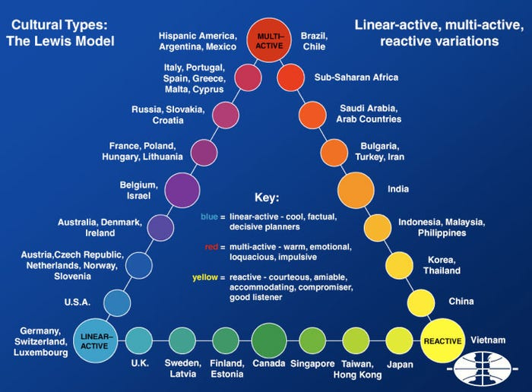  
Image source: [Business insider](https://www.businessinsider.com/the-lewis-model-2013-9?international=true&r=US&IR=T)

# Ethics in software engineering

It is important that a software engineer takes into account the ethical choices that the project will need in order to get as many users as they want. For example; software engineers must ensure that their software is safe and doesn’t have any unwanted consequences for the users or the system it is running on. They also need to take into account the users privacy. What are you going to do with the data of the user when they visit your website or download your app? So from my understanding a software engineer needs to put a few ethical choices as questions whether they want to use some functionality in cost of users. Ethical issues can arise in different areas, such as privacy, security, integrity and social responsibility. Below I’ve written out the ethical choices I applied in my project.

# Ethical choices

## Individual project

The only thing I have really thought hard about is managing the data of users who register on my website. What exactly does the user expect me to do with their data, and why do I need them?

An example would be address data. If a person orders a guitar and he/she wants it delivered to his/her home I obviously need the address data so that the package delivery person from my store, can drive to his/her home.   
Another example is storing the phone number. This is for example to send the user a text message when the package delivery man is on his way or almost there.

You can then put this kind of thing at a Web site under the privacy statement. Such a document contains such things about handling users' data and what a user can expect what a company can do with their data.

Another thing I did is in the security part of the project. As a user you want to control who can edit your data. So in order to protect this, a user can only edit their own data and if they want to edit another users data, they will get an unauthorized exception.  
In this way every user gets to decide what is on their profile and in the database of the company.

## Group project

While developing our group project for World of Content, we as a team have taken into account several of the ethical aspects. The application is designed and developed to help big brands (such as Coca-Cola) to easily see on which website their data is published correctly or not. With this application we hope that brands can have an easy insight in their data, and the data of supermarket websites. So they can take action to correct the published data. No unnecessary data is collected of the users on the site. The only data we collect is the data that is on the website of those supermarkets the brands sell their products to.

However, there would be a few ethical conflicts in the ‘Is It Live’ application. For example, in order for the application to work well we rely on the data that World Of Content provides us for each brand. If the data is incorrect or not available, the applications purpose is gone and brands will no longer have interest in using this application.

As a solution, we have tried to make the application as maintainable and scalable as possible. So that whenever a new brand is added, the application doesn’t crash if there is incorrect or no data available. It will give the user a notification where data is missing and administrators can fix that.

Also, there could be a blockage from the website we scrape the data from. For example, if we send an x amount of requests to jumbo.com, lets say 10 a second, Jumbo could see this as suspicious activity and the application could potentially crash with no clue where the script was with scraping.

In order to ensure this doesn’t happen as often, we limited the requests to 1 each 1.5 seconds. And if the script still does crash, it remembers which URL it had crawled at last, and continues whenever it has the possibility.

Al in all these solutions ensure that the brand, or whoever is visiting the application still has a broad idea on what data is on the website. In this way the brand still can take action if they insist to do so.

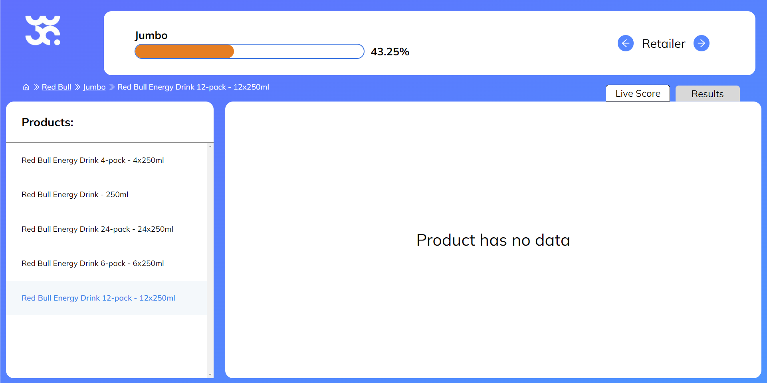

Research

# Cultural Differences

## Introduction

As a software engineer it is very likely that you will at one point in your profession cooperate with individuals from various societies. This combination of societies frequently ends up being enhancing and advantageous, yet may likewise prompt false impressions, clashes and diminished efficiency on the off chance that one isn't adequately mindful of expected social contrasts. It is accordingly critical to know about these distinctions so that these intercultural joint efforts might continue without a hitch.

## Culture

### What is culture?

To understand what differences in cultures are we need to understand what a culture is.  
Culture refers to the cumulative deposit of knowledge, experience, beliefs, values, attitudes, meanings, hierarchies, religion, notions of time, roles, spatial relations, concepts of the universe, and material objects and possessions acquired by a group of people in the course of generations through individual and group striving. It is the systems of knowledge shared by a relatively large group of people.

### Which are well-known dimensions on cultural differences?

One of the most well-known dimensions of cultural differences is Hofstede’s Cultural Dimensions Theory. This theory was created by Dutch social psychologist Geert Hofstede and is based on research conducted in over 100 countries. It includes four primary dimensions:

* power distance
* individualism/collectivism
* masculinity/femininity
* uncertainty avoidance

These dimensions can help us understand how people from different cultures might approach different situations and interact with one another. For example, individualistic cultures tend to value individual autonomy and self-reliance, while collectivistic cultures place a greater emphasis on the needs and goals of the group. Understanding these differences can help us communicate more effectively with people from other cultures.

Sources: <https://www.mindtools.com/a1ecvyx/hofstedes-cultural-dimensions>   
 <https://en.wikipedia.org/wiki/Culture>

# Ethics

## What is ethics in software engineering?

Ethics in software engineering is a crucial topic that is gaining more attention as technology becomes more advanced and prevalent in our lives. As software engineers, we have a responsibility to consider the ethical implications of our work and to make sure that the software we create is used in an ethical manner. This involves taking into account a number of different factors, including privacy, fairness, and bias, as well as the potential impact of our work on society.

## Why is ethics important in software engineering?

One key aspect of software engineering ethics is the issue of privacy. In today's digital age, a vast amount of personal information is collected and stored online, and it is up to software engineers to ensure that this information is handled in a responsible and ethical way. For example, a software engineer may be asked to design a system that collects and stores sensitive personal information, such as financial data or medical records. In this situation, the engineer must carefully consider the potential risks to individuals' privacy and ensure that the system is designed in a way that protects this information from unauthorized access or misuse.

Another important aspect of software engineering ethics is the issue of fairness and bias. As software engineers, we must make sure that the systems we create are fair and unbiased, and do not discriminate against certain individuals or groups. For example, a software engineer may be asked to design an algorithm that is used to make decisions about hiring or promotion in a company. In this case, the engineer must carefully consider the potential for bias in the algorithm and ensure that it is designed in a way that is fair and objective.

## What do you have to do as a software engineer to address ethical aspects in your work?

As a software engineer, there are several steps you can take to address ethical aspects in your work. Some of the most important things you can do include:

1. Understand the ethical implications of your work: It is important to understand the potential ethical implications of the software you are creating and to consider how it might be used. This will help you identify potential ethical issues and take steps to address them.
2. Communicate with your team and stakeholders: Discuss the ethical implications of your work with your team and stakeholders, and make sure everyone is on the same page. This will help ensure that ethical considerations are taken into account throughout the development process.
3. Consider the potential risks to privacy: When working with sensitive personal information, it is important to consider the potential risks to privacy and to take steps to protect this information from unauthorized access or misuse. This might involve implementing strong security measures or limiting access to certain information.
4. Design systems to be fair and unbiased: It is important to ensure that the systems you design are fair and unbiased, and do not discriminate against certain individuals or groups. This might involve conducting testing to identify and address potential biases, or seeking input from diverse stakeholders to ensure that the system is fair and objective.
5. Stay up to date on ethical considerations: The field of software engineering is constantly evolving, and new ethical considerations may arise as technology advances. Stay up to date on the latest developments and best practices in the field, and be prepared to adapt your approach as needed.

## How do you know that your ethical considerations match with those of other software engineers?

There are several ways you can ensure that your ethical considerations match those of other software engineers.

You can join professional organizations or online communities focused on software engineering ethics, and engage with other members to discuss ethical considerations and best practices. You also can attend conferences and workshops focused on software engineering ethics, and listen to presentations and discussions on the topic. This will help you stay up to date on the latest thinking and developments in the field.  
Another option is to read industry publications and articles on software engineering ethics, and pay attention to how different experts and practitioners approach ethical considerations. This will give you a better understanding of the ethical considerations that are commonly accepted in the field.

Discuss ethical considerations with your colleagues: Talk to your colleagues about ethical considerations in software engineering, and compare your approaches and perspectives. This will help you better understand how others in your field approach ethical issues, and identify any potential differences in your views.

Overall, by engaging with others in the field and staying informed about the latest developments, you can ensure that your ethical considerations are in line with those of other software engineers.

Sources: <https://www.scu.edu/ethics/focus-areas/technology-ethics/>   
 <https://www.castsoftware.com/glossary/importance-of-software-engineering-code-of-ethics-future>